Adult Mental Health and Wellbeing Resources
Talking therapy:

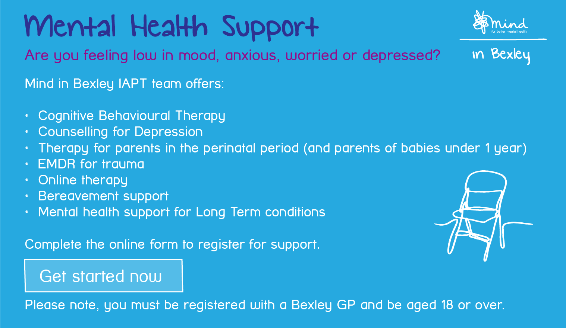
If you are stressed, worried or feeling down right now you can call the MIND in Bexley Wellbeing Line on 0808 196 3806
Open Monday-Friday, 10 am- 3pm

You can also phone the Counselling Matters helpline which is staffed by counsellors and open 9am to 9pm 7 days a week: 0800 047 26000

Crisis resources:

If you feel unable to keep yourself safe please call 999 or attend the nearest Accident and Emergency Department (Queen Elizabeth Hospital Woolwich or Darent Valley Hospital)

At other times of crisis please contact:

Your registered GP surgery Monday to Friday 8am -6.30pm

Oxleas Mental Health Crisis Line: 0800 330 8590 (24 hour service)

Samaritans: call 116 123 or visit www.samaritans.org (24 hour service)

SANEline is a national out-of-hours mental health helpline offering specialist emotional support, guidance and information to anyone affected by mental illness, including family, friends and carers. Open every day of the year from 4.30pm to 10.30pm on 0300 304 7000.

The Bexley Crisis Café is a safe and friendly place to come to if you are experiencing severe emotional or psychological distress. The service provides access to mental health support and advice from mental health and wellbeing professionals.

Opening times: 6 pm to 10 pm from Monday to Sunday and Bank Holidays.
Location: Mind in Bexley 2a Devonshire Road, Bexleyheath, DA6 8DS

Further Crisis resources: https://mindinbexley.org.uk/help

Depression:

24 hour text support service: https://giveusashout.org/
Online emotional wellbeing and mental health support: https://www.qwell.io/
Support organisation: http://depressionuk.org
Advice and practical tips to help you look after your mental health and wellbeing: https://www.nhs.uk/oneyou/every-mind-matters/
Signs, symptoms and treatment guide: https://web.ntw.nhs.uk/selfhelp/leaflets/Depression%20and%20Low%20Mood.pdf
How to challenge unhelpful thoughts: https://mindinbexley.org.uk/wp-content/uploads/2020/03/TalkPlus_Cognitive_Restructuring.pdf
Mindfulness, meditation and relaxation resources: https://mindinbexley.org.uk/mindfulness
Resources to help you look after your physical health: https://mindinbexley.org.uk/physical-activity
Cognitive behavioural therapy self- help: https://www.getselfhelp.co.uk/depression.htm
Silvercloud online cognitive behavioural therapy programme: https://mindinbexley.silvercloudhealth.com/onboard/bexley/

Book recommendation: ‘The Chimp Paradox: The Mind Management Programme to Help You Achieve Success, Confidence and Happiness by Professor Steve Peters

Anxiety:

24 hour text support service: https://giveusashout.org/
Online emotional wellbeing and mental health support: https://www.qwell.io/

Support (online, phone, text), resources and courses: https://www.anxietyuk.org.uk/ Helpline: 03444 775 774 - Mon-Fri: 9:30am - 5.30pm

Advice and self-help resources for anxiety, panic attacks, phobias, Obsessive Compulsive Disorder and other anxiety-related conditions: www.nopanic.org.uk Helpline 0300 772 9844 Every day 10am -10pm

Signs, symptoms and self-help strategies: https://www.moodjuice.scot.nhs.uk/anxiety.asp

Support and advice: https://www.mind.org.uk/information-support/types-of-mental-health-problems/anxiety-and-panic-attacks/about-anxiety/

Cognitive behavioural therapy self-help: http://getselfhelp.co.uk/anxiety.htm

Bereavement:

Pre- bereavement and bereavement support and counselling: CRUSE Bexley and Bromley

www.cruse.org.uk/get-help/local-services/south-east/bexley-and-bromley Helpline: 0808 808 1677
Practical guidance and support following the loss of a loved one: National Bereavement Service
https://thenbs.org/
Peer-to-peer support network to anyone who’s been widowed at a young age: WAY- Widowed and Young
www.widowedandyoung.org.uk

Signposting website for the bereaved and anyone supporting them: At a Loss
www.ataloss.org

Helpline for people affected by the death of a child under any circumstances: The Child Death Helpline
www.childdeathhelpline.org.uk Helpline: 0800 282 986

Postnatal depression:
Support for mothers suffering postnatal illness and their families: Association for Postnatal Illness
https://apni.org/
Pre- and postnatal depression advice and support for parents: PANDAS
www.pandasfoundation.org.uk Helpline 0808 1961 776 11am -10pm Everyday

Domestic Abuse:
Support and advice: National Domestic Abuse Helpline
www.nationaldahelpline.org.uk 24 hour Helpline 0808 2000 247
Information, support and advice: Womens’ Aid
www.womensaid.org.uk
Helpline for men affected by domestic abuse: Respect Men’s Advice Line
www.mensadviceline.org.uk Helpline: 0808 8010 327 Monday- Friday 9am-8pm
Support and advice: Solace
www.solacewomensaid.org Helpline: 0808 802 556580
Information, support and signposting for men affected by domestic abuse and their friends and family: ManKind Initiative
www.mankind.org.uk Helpline: 01823 334 244
Local suppport organisation: Bexley Womens’ Aid
www.bexleywomensaid.org.uk Helpline: 020 8302 1536 Monday -Friday 9.30am -12.30pm
bexleywomensaid.org.uk
bexleywomensaid.org.uk

Psychoses:
Emotional support, guidance and information to anyone affected by mental illness, including families, friends and carers: SANE
http://www.sane.org.uk/ Helpline: 0300 304 7000 Monday to Friday 4.30pm to 10.30pm
Advice, information and support: Rethink Mental Illness
www.rethink.org Advice line: 0808 801 0525 9.30 am- 4pm Monday to Friday
Support and advice for Bipolar: Bipolar UK
www.bipolaruk.org

Eating Disorders:
Support for those affected by eating disorders: Beat eating disorders
www.beateatingdisorders.org.uk Helpline: 0808 801 0677
Support and self help groups for those affected by eating disorders: Seed Eating Disorder Support Service
https://seedeatingdisorders.org.uk/
Support for those affected by eating disorders: Anorexia Bulimia Care
www.anorexiabulimiacare.org.uk Helpline: 03000 11 12 13

Wellbeing Apps:

Silvercloud
Clear fear
Headspace
Calm Harm
Calm

Apps for depression, anxiety, physical wellbeing and eating disorders: https://mindinbexley.org.uk/apps

Book recommendations for mental health and well being: https://reading-well.org.uk/books/books-on-prescription/mental-health

Mental wellbeing audioguides: https://www.nhs.uk/mental-health/self-help/guides-tools-and-activities/mental-wellbeing-audio-guides/

Sleep:

Getting a good night’s sleep self help guide: https://mindinbexley.org.uk/wp-content/uploads/2020/03/SleepHygiene.pdf

How to cope with sleep problems-Advice from MIND: https://www.mind.org.uk/information-support/types-of-mental-health-problems/sleep-problems/about-sleep-and-mental-health/

How to cope with sleep problems self- help resoures from MIND: https://mindinbexley.org.uk/self-help-materials

